1. Introduction to the Stock Market

What is a Stock Market?
A marketplace where investors buy and sell ownership shares of companies.
Example:
- If a company has 1,000 shares and you own 100 shares, you own 10% of that company.

Why Companies Issue Shares
- Raise capital
- Expand business
- Reduce debt
- Fund new projects

Why Investors Buy Shares
- Capital appreciation
- Dividends
- Wealth creation
- Passive income

2. History of Stock Markets

Evolution
- Dutch East India Company (first publicly traded company)
- Development of stock exchanges
- Electronic trading

Major Stock Exchanges
- New York Stock Exchange
- NASDAQ
- Bombay Stock Exchange
- National Stock Exchange of India

3. Market Participants

Retail Investors
Individual traders

Institutional Investors
- Mutual Funds
- Pension Funds
- Insurance Companies

Brokers
Middlemen who execute trades
Examples:
- Zerodha
- Groww
- Angel One

Market Makers
Provide liquidity

Regulators
India:
- Securities and Exchange Board of India
USA:
- U.S. Securities and Exchange Commission

4. Types of Markets

Primary Market
IPO market

IPO
Initial Public Offering
Example:
Company sells shares to the public for the first time.

Secondary Market
Investors trade existing shares.

5. Types of Financial Instruments

Equity Shares
Ownership in company

Preference Shares
Fixed dividend priority

Bonds
Debt instruments

ETFs
Exchange Traded Funds

Mutual Funds

REITs
Real Estate Investment Trusts

Derivatives
- Futures
- Options

6. Understanding Stocks

Large Cap
Established companies

Mid Cap
Growing companies

Small Cap
High growth, high risk

Blue Chip Stocks
Strong financial companies
Example:
- Apple Inc.
- Microsoft Corporation

7. Stock Market Terminology

Bid Price
Buyer's price

Ask Price
Seller's price

Spread
Difference between bid and ask

Volume
Number of shares traded

Liquidity
Ease of buying/selling

Volatility
Price fluctuations

Market Capitalization
Market Cap = Share Price × Total Shares

8. How Trading Works

Step 1
Place order

Step 2
Broker receives order

Step 3
Exchange matches order

Step 4
Trade executed

Step 5
Settlement completed

9. Order Types

Market Order
Buy immediately

Limit Order
Buy at desired price

Stop Loss Order
Limits loss

Stop Limit Order

Bracket Order

Cover Order

10. Stock Indices
Represent overall market performance.
India:
- NIFTY 50
- SENSEX
USA:
- S&P 500
- Dow Jones Industrial Average

11. Fundamental Analysis
Used for long-term investing.

Financial Statements

Balance Sheet
- Assets
- Liabilities
- Equity

Income Statement
- Revenue
- Expenses
- Profit

Cash Flow Statement

Important Ratios

EPS
Earnings Per Share

P/E Ratio
Price ÷ Earnings

ROE
Return on Equity

ROCE
Return on Capital Employed

Debt-to-Equity

Current Ratio

Dividend Yield

12. Technical Analysis
Used for trading.

Price Action

Support
Price floor

Resistance
Price ceiling

Trend Types

Uptrend

Downtrend

Sideways Market

Candlestick Patterns
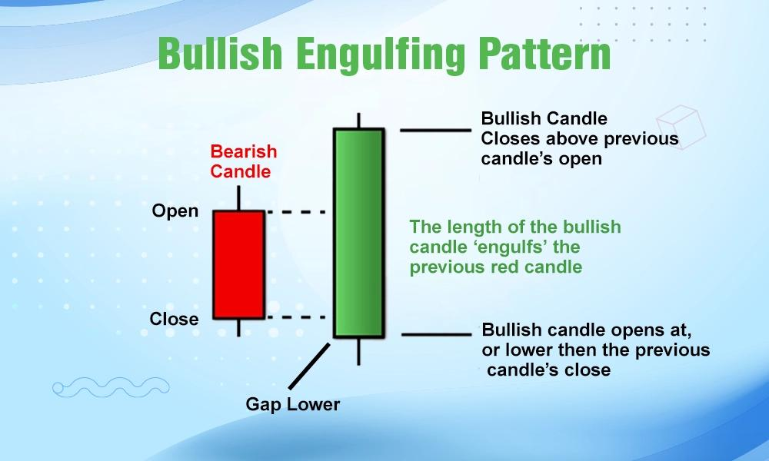
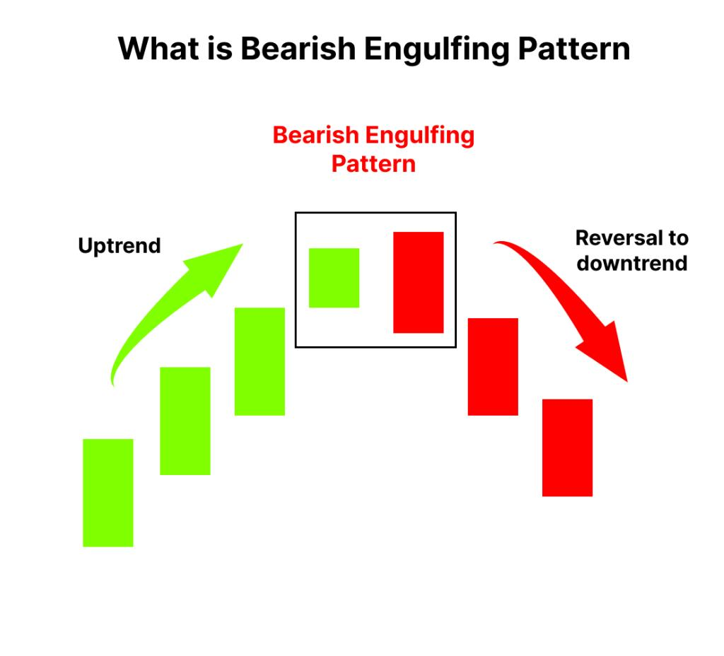
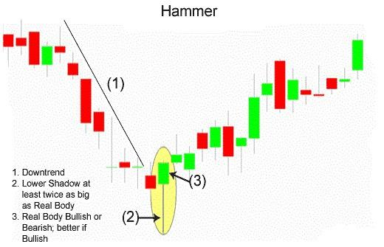


Doji

Hammer

Hanging Man

Morning Star

Evening Star

Bullish Engulfing

Bearish Engulfing

Chart Patterns

Head and Shoulders

Double Top

Double Bottom

Cup and Handle

Ascending Triangle

Descending Triangle

Flag Pattern

Pennant Pattern

13. Technical Indicators

Moving Average

SMA

EMA

RSI
Relative Strength Index
Measures momentum

MACD
Moving Average Convergence Divergence

Bollinger Bands

VWAP

Fibonacci Retracement

14. Market Psychology

Fear

Greed

FOMO
Fear Of Missing Out

Panic Selling

Herd Mentality

15. Risk Management
Most important topic.

Position Sizing

Stop Loss

Risk-Reward Ratio
Example:
Risk = ₹100
Reward = ₹300
Ratio = 1:3

Portfolio Diversification
Don't invest all money in one stock.

16. Types of Trading

Scalping
Seconds to minutes

Intraday Trading
Same day

Swing Trading
Days to weeks

Positional Trading
Weeks to months

Long-Term Investing
Years

17. Futures Market
Agreement to buy/sell in future.
Topics:
- Lot size
- Margin
- Mark-to-market
- Leverage

18. Options Trading
Advanced section.

Call Option
Bullish view

Put Option
Bearish view

Greeks

Delta

Gamma

Theta

Vega

Rho

Strategies

Covered Call

Iron Condor

Straddle

Strangle

Bull Call Spread

Bear Put Spread

19. Portfolio Management

Asset Allocation
- Stocks
- Bonds
- Gold
- Cash

Rebalancing

Wealth Creation

20. Dividend Investing

Dividend Yield

Dividend Growth

Ex-Dividend Date

Record Date

21. Economic Factors

Inflation

Interest Rates

GDP

Employment Data

Government Policies

Budget Announcements

22. Sector Analysis

Banking

IT

Pharma

FMCG

Auto

Energy

Infrastructure

Telecom

23. Market Cycles
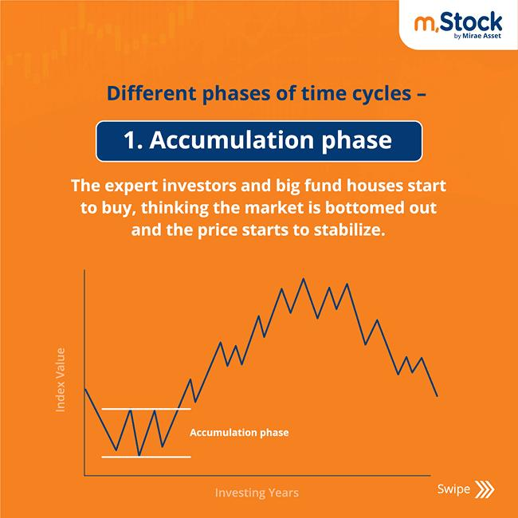
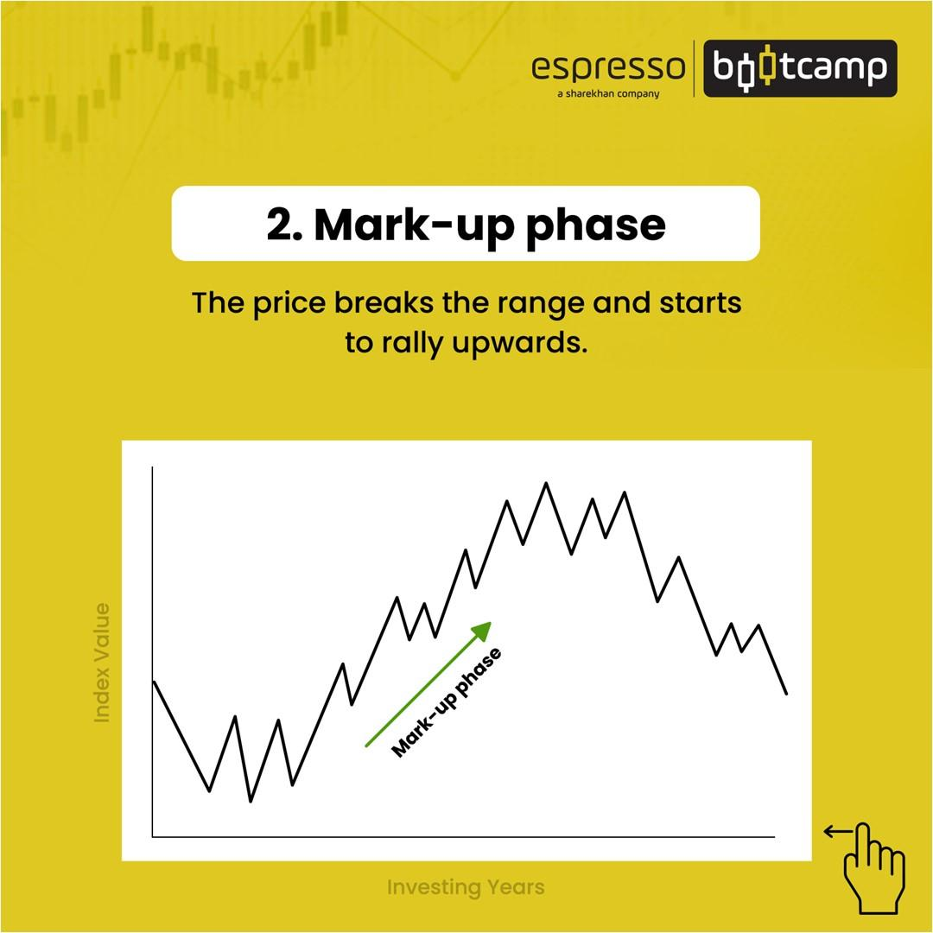
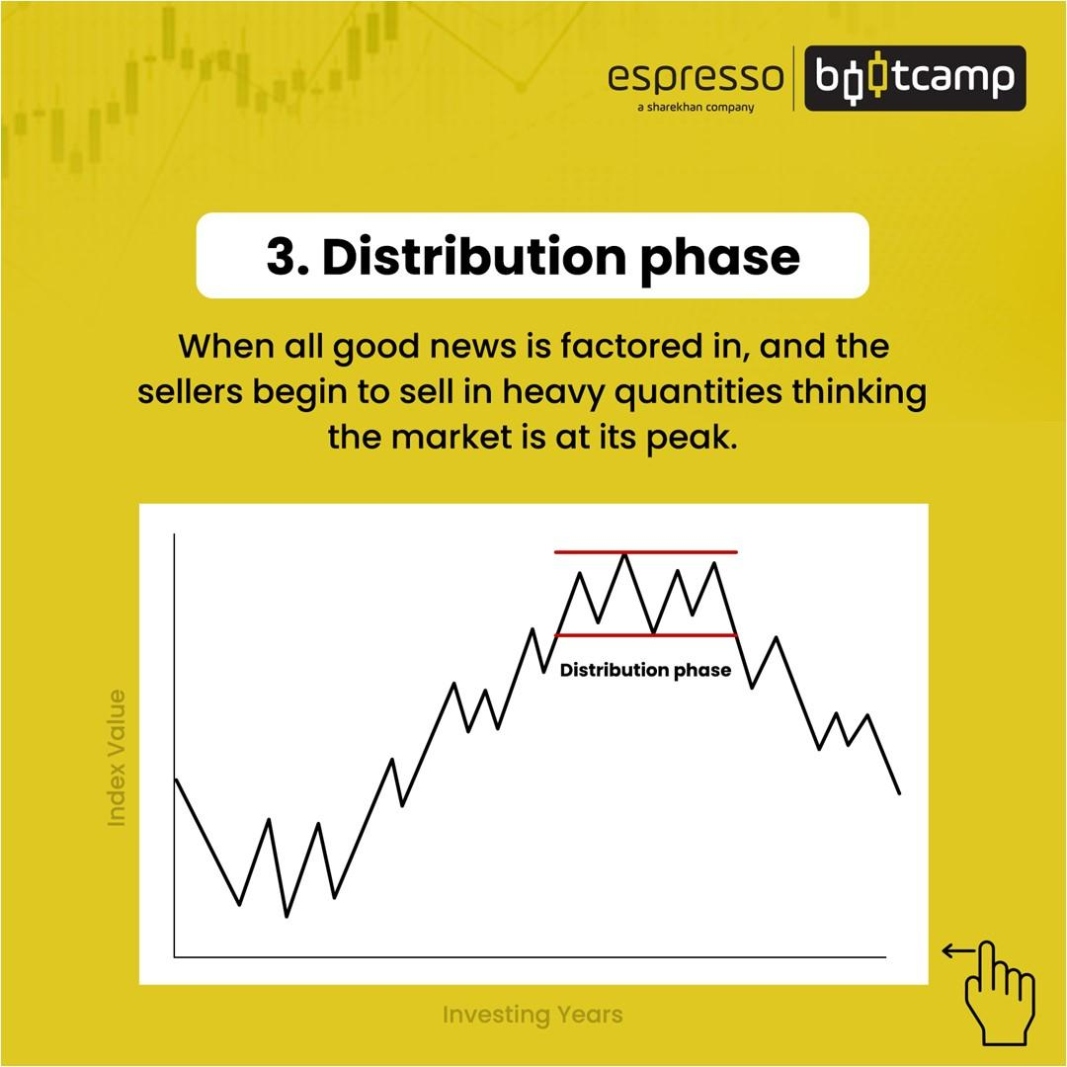
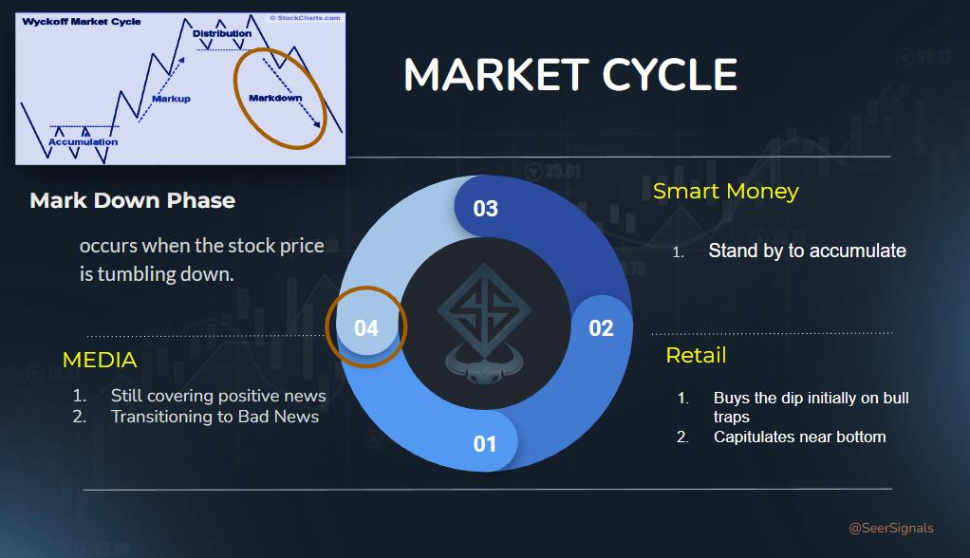

Accumulation

Markup

Distribution

Markdown

24. Advanced Concepts

Quantitative Trading

Algorithmic Trading

High Frequency Trading

Arbitrage

Pair Trading

Market Breadth

Dark Pools

Institutional Order Flow

25. Common Mistakes
❌ No stop loss
❌ Overtrading
❌ Emotional trading
❌ Following tips blindly
❌ Excessive leverage
❌ Investing without research

26. Professional Trading Plan

Daily Routine
- Check global markets
- Analyze sectors
- Identify setups
- Define entry
- Define stop loss
- Define target
- Execute trade
- Maintain journal

27. Learning Roadmap

Beginner
- Market basics
- Order types
- Candlesticks
- Risk management

Intermediate
- Technical indicators
- Swing trading
- Fundamental analysis

Advanced
- Options
- Futures
- Portfolio management
- Algorithmic trading

Expert
- Quantitative models
- Institutional analysis
- Macro economics
- Derivatives strategies
This roadmap covers roughly 95% of the stock market knowledge tree, from absolute beginner concepts to professional-level trading and investing topics. If you want, I can also create a 1,000+ page structured Stock Market Master Course outline with chapter-by-chapter lessons, practice exercises, quizzes, trading simulations, and a roadmap specifically for Indian markets (NSE/BSE).

